**Assignment-1**

Power BI is a business analytics service by Microsoft. It aims to provide interactive visualizations and business intelligence capabilities with an interface simple enough for end users to create their own reports and dashboards.

* **Report view page**

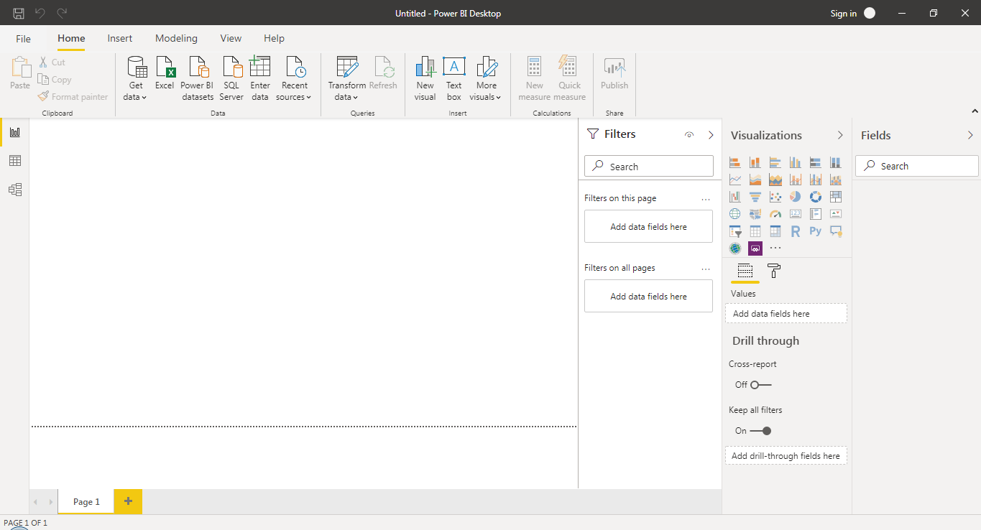

* **Documents**

We can switch between Report, Data, and Relationship views by selecting the icons in the left-hand navigation pane:

Document on Report View:

Power BI Desktop includes a Report view, where you can create any number of report pages with visualizations. Report view in Power BI Desktop provides a similar design experience to the report's editing view in the Power BI service. You can move visualizations around, copy and paste, merge, and so on, screenshot as shown above.

Document on Data View:

Report data can come from multiple sources of data. First step in designing a Power BI Report Builder report is to create data sources and datasets that represent the underlying report data. Each data source includes data connection information. Each dataset includes a query command that defines the set of fields to use as data from a data source. To visualize data from each dataset, when the report is processed, the queries run on the data source, and each data region expands as needed to display the query results for the dataset. Screenshot as shown below.

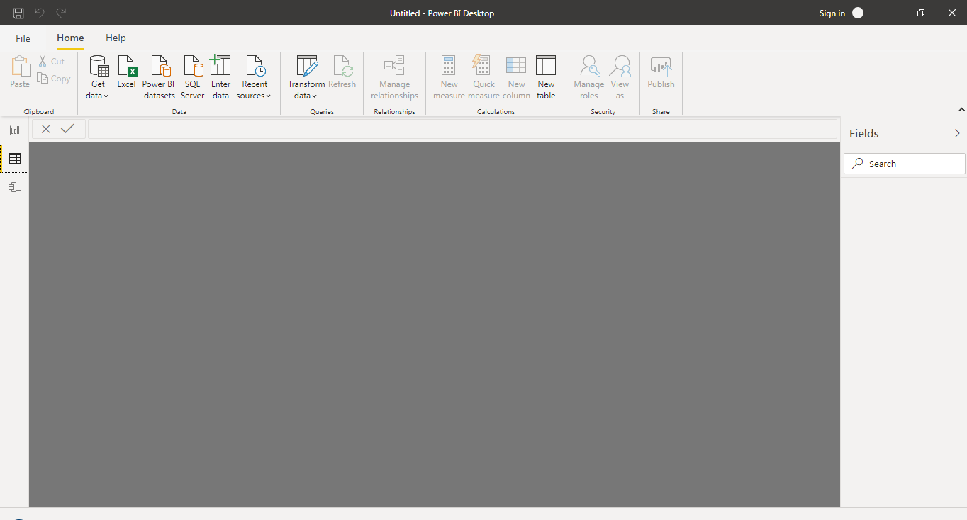

Document on Model View:

Model view is created by setting up of layouts with dimension table and fact table.

**Dimension tables** describe business entities—the things you model. Entities can include products, people, places, and concepts including time itself. The most consistent table you'll find in a star schema is a date dimension table. A dimension table contains a key column (or columns) that act as a unique identifier, and descriptive columns.

**Fact tables** store observations or events, and can be sales orders, stock balances, exchange rates, temperatures, etc. A fact table contains dimension key columns that relate to dimension tables, and numeric measure columns. The dimension key columns determine the dimensionality of a fact table, while the dimension key values determine the granularity of a fact table. For example, consider a fact table designed to store sale targets that have two dimension key columns Date and Product Key. It's easy to understand that the table has two dimensions. The granularity, however, can't be determined without considering the dimension key values. In this example, consider that the values stored in the Date column are the first day of each month. In this case, the granularity is at month-product level.

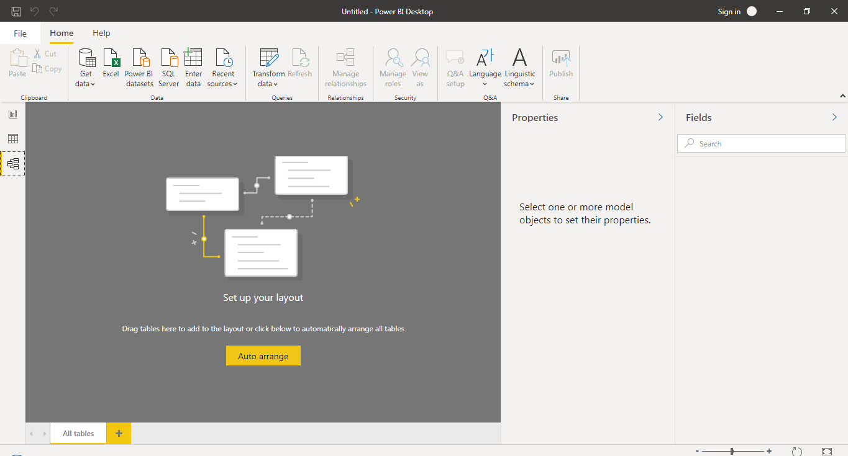

Document on Power Query Editor:

Power BI Desktop also comes with Power Query Editor. Use Power Query Editor to connect to one or many data sources, shape and transform the data to meet the requirements, and then load that model into Power BI Desktop.

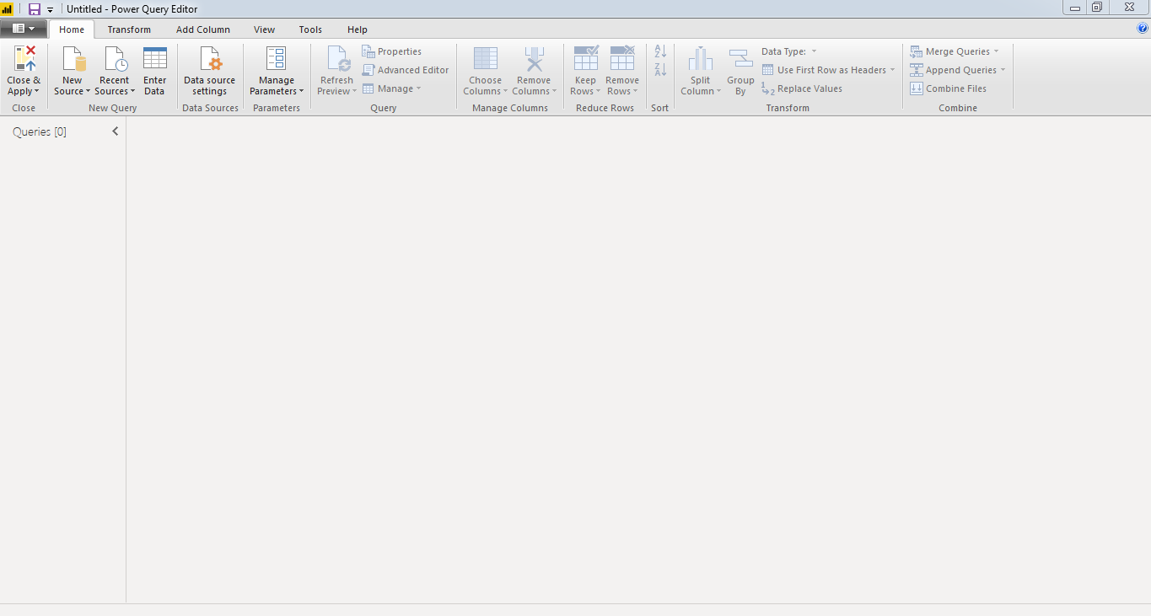

Document on Advance Editor:

The Advanced Editor lets you see the code that Power Query Editor is creating with each step. To launch the advanced editor, select View from the ribbon, then select Advanced Editor.

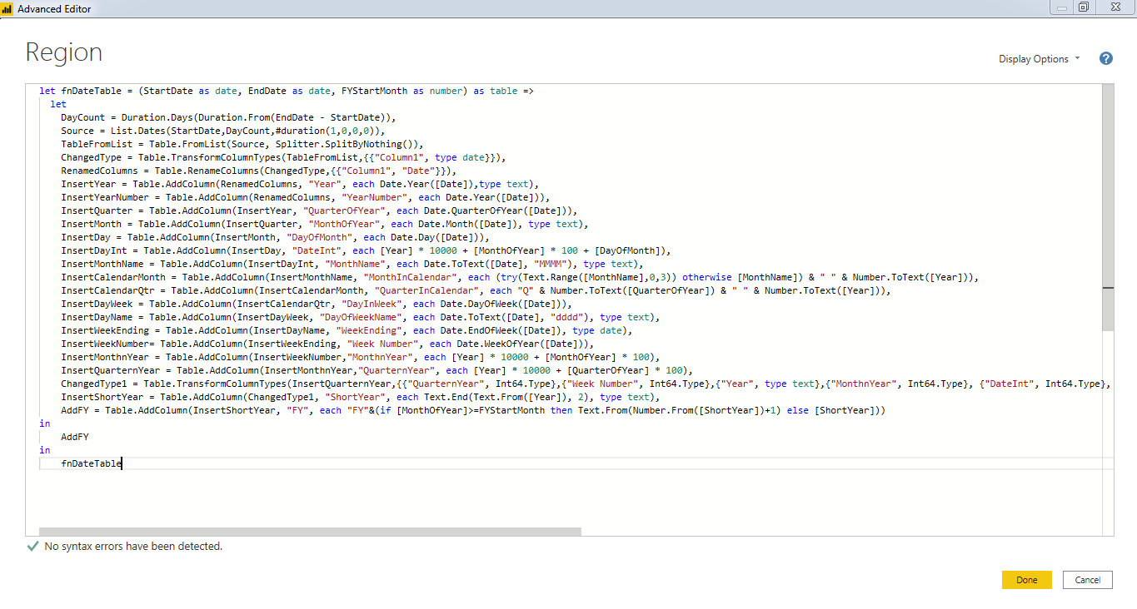

Power BI Desktop:

Power BI Desktop is free applications you install on your local computer that lets you connect to, transform, and visualize your data. With Power BI Desktop, you can connect to multiple different sources of data, and combine them (often called modeling) into a data model. This data model lets you build visuals, and collections of visuals you can share as reports, with other people inside your organization. Most users who work on business intelligence projects use Power BI Desktop to create reports, and then use the Power BI service to share their reports with others.

Price: Free Application

Power BI Pro:

Power BI Pro is an individual user license that lets users read and interact with reports and dashboards that others have published to the Power BI service. Users with this license type can share content and collaborate with other Power BI Pro users.

Price: Rs 660/Month

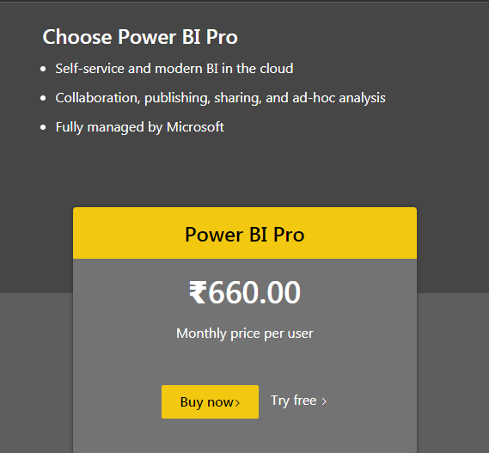

Power BI Premium:

You can use Power BI Premium to get dedicated and enhanced resources for the organization, so users in the organization can use the Power BI service with better performance and responsiveness. For example, with a Power BI Premium subscription, you and your organization's users get access to:

* Greater scale and performance
* Flexibility to license by capacity
* Unify self-service and enterprise BI
* Extend on-premises BI with Power BI Report Server
* Support for data residency by region (Multi-Geo)
* Share data with anyone without purchasing a per-user license

Price: Rs 3,30,190/Monthly price per dedicated cloud compute and storage resource with annual subscription

